Index
- Motto
- System Architecture
- Database
- User Interface
- Hosting
- Glossary

Motto

System Architecture

Database

Entity Relationship Diagram
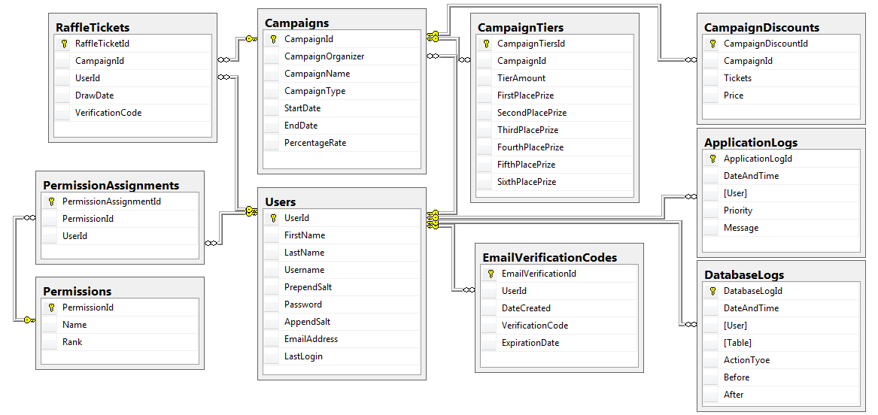

Tables

User

The user table will house all user information.

FirstName: The first name of the user, will be used if we need to send an email to them.
LastName: The first name of the user, will be used if we need to send an email to them.
Username: The username the user chose to sign in with.
PrependSalt: A random collection of characters prepended in the hashing process.
Password: The password of the user, hashed using (sha256?).
AppendSalt: A random collection of characters appended in the hashing process.
EmailAddress: The email address of the user, used if we wish to send them an email.
LastLogin: The date and time of the users last login.

Permissions

PermissionAssignments

Campaign

CampaignDetails

CampaignTiers

CampaignDiscounts

EmailVerificationCodes

DatabaseLogs

ApplicationLogs

User Interface

Hosting

Glossary

